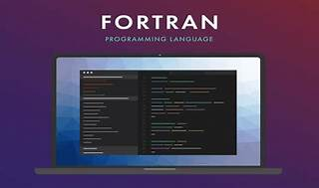

Explore

**Fortran**, a mature and versatile language, is specifically suited for computationally intensive applications in science and engineering. [It has been designed for high-performance parallel programming, offers strong static typing, and allows expressing mathematical operations over large arrays with ease1](https://fortran-lang.org/).

Here are **five free reference links** where you can learn Fortran:

1. [**The Fortran Programming Language**](https://fortran-lang.org/): This official website provides comprehensive information about Fortran, including tutorials, features, and how to get started[1](https://fortran-lang.org/).
2. [**Fortran on Wikipedia**](https://en.wikipedia.org/wiki/Fortran): Learn about Fortran’s history, development, and its suitability for numeric computation and scientific computing[2](https://en.wikipedia.org/wiki/Fortran).
3. [**Quickstart Tutorial**](https://fortran-lang.org/en/learn/quickstart/index.html): A beginner-friendly tutorial covering Fortran syntax, types, variables, arrays, control flow, and functions[3](https://fortran-lang.org/en/learn/quickstart/index.html).
4. **Fortran Tutorial**: Tutorialspoint offers a step-by-step guide to Fortran, with examples and exercises.
5. **Fortran 90/95 Programming Manual**: Lahey’s manual provides detailed information on Fortran 90/95 features and usage.

Happy learning! 🚀📚